Ideation Phase
Brainstorm & Idea Prioritization
Template
Date | 27 JUNE 2025
Team ID | NM2025TMID00743
Project Name | To Supply Leftover Food To Poor
Maximum Mark | 4 Marks

To Supply Leftover Food To Poor Template :
Every day, large amounts of edible food get wasted in restaurants, hotels, functions and
households. At the same time, thousands of poor people struggle without proper food.
There is no proper system to connect places that have surplus food with people who need
food immediately. Because of this gap, good quality food is thrown away instead of being
reused. Therefore, a smart solution is required to collect leftover food safely, store it
properly, and deliver it to the needy people on time without affecting the quality of the food
Step-1: Team Gathering, Collaboraton and Select the Problem Statement:

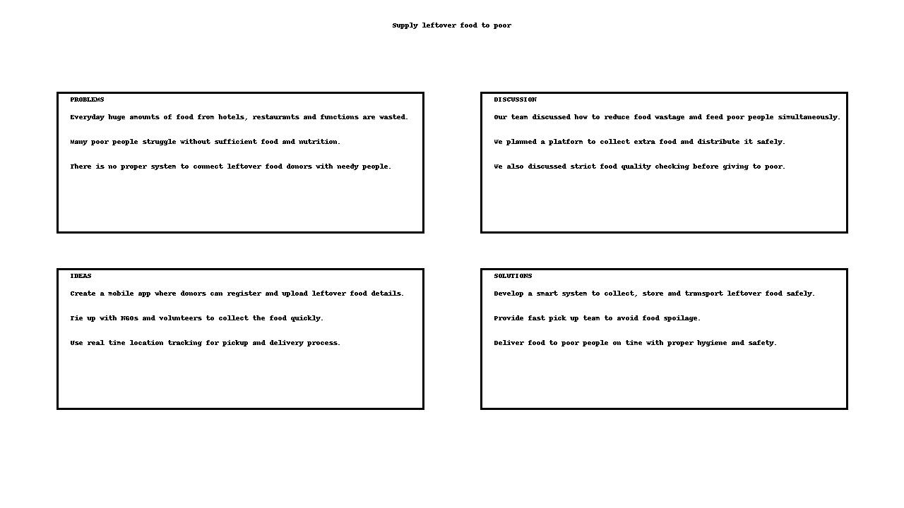
Reference:https://www.canva.com/templates/EADap2EnLxE-brainstorm-mind-map/

Step-2: Brainstorm, Idea Listng and Grouping:

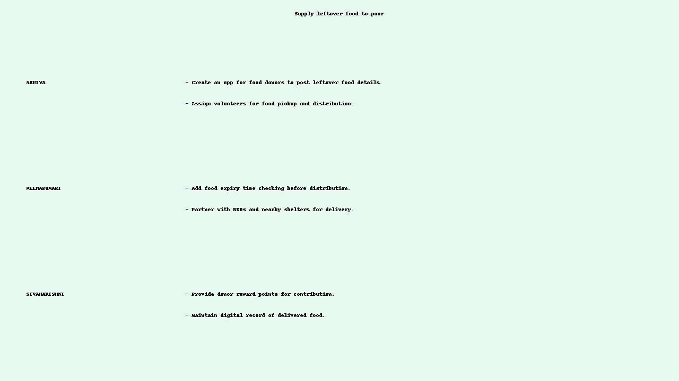

Step-2: Brainstorm, Idea Listng and Grouping:
Fig2: I mage that describes the work done by teammates.
Brainstorm:
Team members share ideas freely to explore solutons without judgment, encouraging creatvity and
partcipaton.
Idea Listng:
All ideas from the session are writen down to capture every suggeston and ensure no input is
overlooked.
Grouping:
Similar ideas are organized into categories to identfy paterns, highlight priorites, and simplify
decision-making.
Acton Planning:
Chosen ideas are turned into clear steps with assigned responsibilites and tmelines.

Step-3: Idea Prioritzaton:
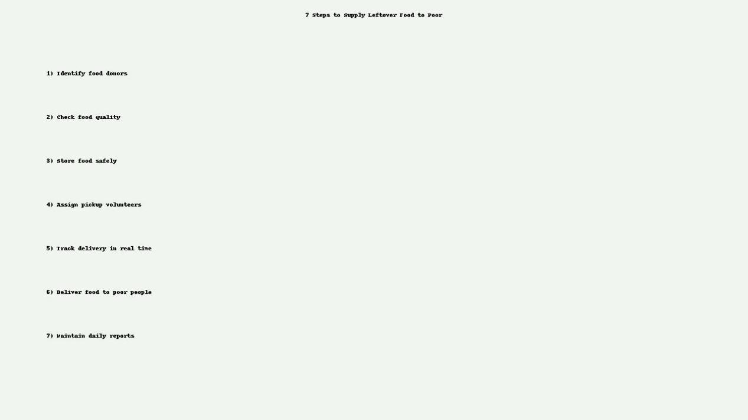

Idea Prioritization:
In this project, idea prioritization helped us decide which ideas should be executed first to make the system successful. The highest priority was given to creating a proper mobile application to connect leftover food donors with NGOs and volunteers. Food quality checking and expiry time monitoring were placed as second priority to make sure that the food delivered to poor people is safe for consumption. Real time location tracking, volunteer assignment, vehicle arrangement and NGO partnership were added in the next priority order. This prioritization makes our plan structured and supports smooth implementation.

窗体底端

